## Sql Tutorial

Base de datos **adventureWorks2019**

<https://mode.com/sql-tutorial/sql-count>

<https://app.mode.com/editor/sqlmariano/reports/9ea845594d0a/queries/79d7a42e19c0>

Contenido

Sql Tutorial 1

Intermediate SQL 2

Aggregate functions 2

Counting individual columns 3

Sql sum 3

Min and Max 3

AVG 3

Group by 4

GROUP BY column numbers 4

Using GROUP BY with ORDER BY 4

HAVING 5

query clause order 5

CASE 5

Adding multiple conditions to a CASE statement 5

Using CASE with aggregate functions 7

Using SQL DISTINCT for viewing unique values 10

Using DISTINCT in aggregations 11

DISTINCT performance 11

Joins 12

Inner Join 12

Filtering in the ON clause 16

El AND se ejecuta antes del join, es como un where para una sola tabla 17

The SQL FULL JOIN command 21

The SQL UNION operator 22

Using comparison operators with joins 24

Self joining tables 25

# [Intermediate SQL](https://mode.com/sql-tutorial/intro-to-intermediate-sql)

## Aggregate functions

* [COUNT](https://mode.com/sql-tutorial/sql-count) counts how many rows are in a particular column.
* [SUM](https://mode.com/sql-tutorial/sql-sum) adds together all the values in a particular column.
* [MIN](https://mode.com/sql-tutorial/sql-min-max) and [MAX](https://mode.com/sql-tutorial/sql-min-max) return the lowest and highest values in a particular column, respectively.
* [AVG](https://mode.com/sql-tutorial/sql-avg) calculates the average of a group of selected values.

Count(1) == count(*)

Sql top 100 , otros limit 100

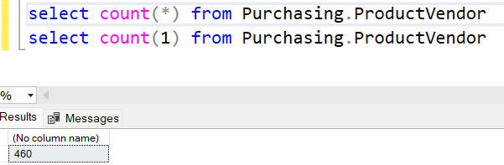

### Counting individual columns

Count columna cuenta solo los que no son nulos de la columna.

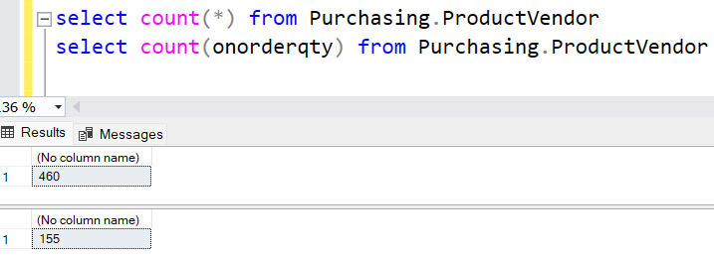

### Sql sum

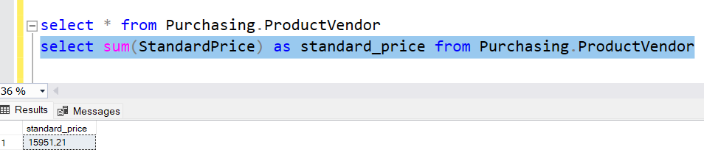

### Min and Max

Pueden ser usados con no numerical columns,

MIN will return the lowest number, earliest date, close alphabetically to "A" as possible.

MAX returns the highest number, the latest date, or the non-numerical value closest alphabetically to "Z."

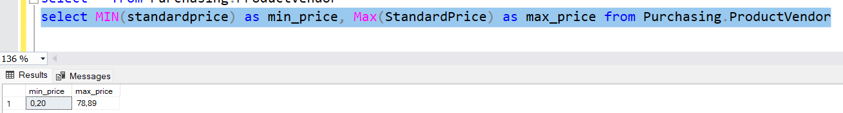

### AVG

it can only be used on numerical columns

Ignores nulls completely.

SELECT AVG(high)

FROM tutorial.aapl_historical_stock_price

WHERE high IS NOT NULL

Es lo mismo

SELECT AVG(high)

FROM tutorial.aapl_historical_stock_price

### Group by

SELECT year,

COUNT(*) AS count

FROM tutorial.aapl_historical_stock_price

GROUP BY year

SELECT year,

month,

COUNT(*) AS count

FROM tutorial.aapl_historical_stock_price

GROUP BY year, month

### GROUP BY column numbers

SELECT year,

month,

COUNT(*) AS count

FROM tutorial.aapl_historical_stock_price

GROUP BY 1, 2

### Using GROUP BY with ORDER BY

select year, month, count(*) as count

from aapl_historical_stock_price

group by year, month

order by year, month

### HAVING

is the 'clean' way to filter a query that has been agregated,

but this is also commonly done using a subquery

select year, month, max(high) as month_high

from aapl_historical_stock_price

group by year, month

having max(high) > 400

order by year, month

### query clause order

group by

having

order by

### CASE

select player_name, year,

case when year = 'SR' then 'yes' else null end as is_a_senior

from college_football_players

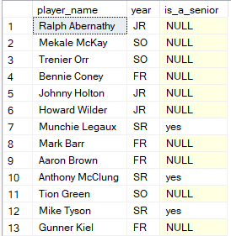

### Adding multiple conditions to a CASE statement

select player_name, year,

weight,

case when weight > 250 then 'over 250'

when weight > 200 AND weight <= 250 then '201 - 250'

when weight > 175 AND weight <= 200 then '176 - 200'

else '175 or under' end as weight_group

from college_football_players

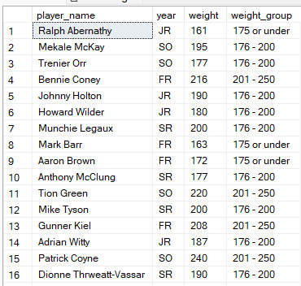

select player_name,

case when year = 'FR' and position = 'WR' then 'frosh_wr'

else null end as sample_case_statement

from college_football_players

Write a query that selects all columns from benn.college_football_players

and adds an additional column that displays the player's name if that player is a junior or senior.

select full_school_name, school_name, player_name, position,

height, weight, year, hometown, state, id,

case when year = 'SR' or year = 'JR' then player_name

ELSE null end as player_name

from college_football_players

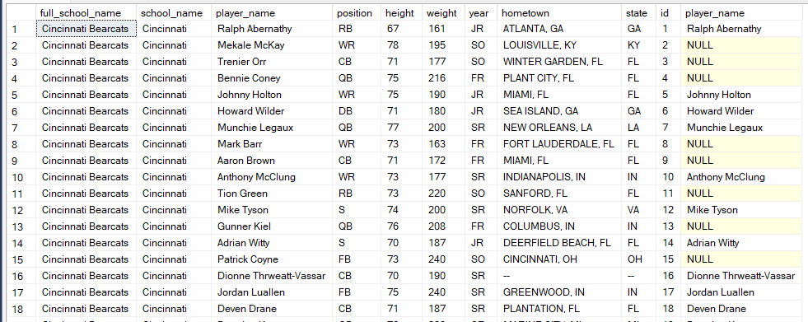

### Using CASE with aggregate functions

-- para poder contar también los nulos

select

case when year = 'FR' then 'FR' else 'NOT FR' END AS year_group,

count(1) as count

from college_football_players

group by case when year = 'FR' then 'FR' else 'NOT FR' END

select year, count(1) as count

from college_football_players

group by year

--counting multiple conditions

select case when year = 'FR' then 'FR'

when year = 'SO' then 'SO'

when year = 'JR' then 'JR'

when year = 'SR' then 'SR'

ELSE 'NO YEAR DATA' END AS year_group,

count(1) as count

from college_football_players

group by case when year = 'FR' then 'FR'

when year = 'SO' then 'SO'

when year = 'JR' then 'JR'

when year = 'SR' then 'SR'

ELSE 'NO YEAR DATA' END

/*

Write a query that counts the number of 300lb+ players for each of the following regions:

West Coast (CA, OR, WA), Texas, and Other (everywhere else).

*/

select

case when state IN ('CA', 'OR', 'WA') THEN 'West Coast'

when state = 'TX' THEN 'TEXAS'

ELSE 'OTHER' end AS regions,

count(1) count

from college_football_players

where weight >= 300

group by case when state IN ('CA', 'OR', 'WA') THEN 'West Coast'

when state = 'TX' THEN 'TEXAS'

ELSE 'OTHER' end

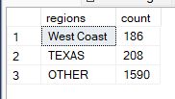

--Write a query that calculates the combined weight of all underclass players (FR/SO) in California

--as well as the combined weight of all upperclass players (JR/SR) in California.

select

case when year in ('FR','SO') THEN 'underclass players'

when year in ('JR','SR') THEN 'upperclass players'

else '' end as players,

sum(weight) combined_weight

from college_football_players

where state = 'CA'

group by case when year in ('FR','SO') THEN 'underclass players'

when year in ('JR','SR') THEN 'upperclass players'

else '' end

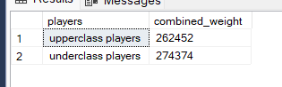

--Using CASE inside of aggregate functions

--want to show data horizontally.

SELECT CASE WHEN year = 'FR' THEN 'FR'

WHEN year = 'SO' THEN 'SO'

WHEN year = 'JR' THEN 'JR'

WHEN year = 'SR' THEN 'SR'

ELSE 'No Year Data' END AS year_group,

COUNT(1) AS count

FROM college_football_players

GROUP BY CASE WHEN year = 'FR' THEN 'FR'

WHEN year = 'SO' THEN 'SO'

WHEN year = 'JR' THEN 'JR'

WHEN year = 'SR' THEN 'SR'

ELSE 'No Year Data' END

--And re-orient it horizontally

select count(case when year = 'FR' THEN 'FR' ELSE NULL END ) as fr_count,

count(case when year = 'SO' THEN 'SO' ELSE NULL END ) as so_count,

count(case when year = 'JR' THEN 'JR' ELSE NULL END ) as jr_count,

count(case when year = 'SR' THEN 'SR' ELSE NULL END ) as sr_count

FROM college_football_players

--Write a query that displays the number of players in each state, with FR, SO, JR, and SR players in separate columns

--and another column for the total number of players.

--Order results such that states with the most players come first.

SELECT

state ,

COUNT(CASE WHEN year = 'FR' then 'FR' else null end) as fr_count,

COUNT(CASE WHEN year = 'SO' then 'SO' else null end) as so_count,

COUNT(CASE WHEN year = 'JR' then 'JR' else null end) as jr_count,

COUNT(CASE WHEN year = 'SR' then 'SR' else null end) as sr_count,

count(1) total_number_players

FROM college_football_players

group by state

order by total_number_players desc

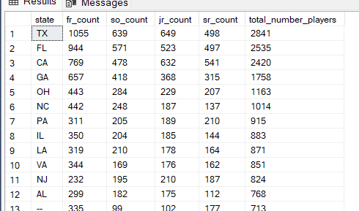

--Write a query that shows the number of players at schools with names that start with A through M,

--and the number at schools with names starting with N - Z.

select

count(case when school_name < 'n' then school_name ELSE NULL end) as 'A-M',

count(case when school_name >= 'n' then school_name ELSE NULL end) as 'N-Z'

FROM college_football_players

### Using SQL DISTINCT for viewing unique values

--when you want to look at only the unique values in a particular column

SELECT DISTINCT month

FROM aapl_historical_stock_price

SELECT DISTINCT year, month

FROM aapl_historical_stock_price

order by year, month

--Write a query that returns the unique values in the year column, in chronological order.

select distinct year

from aapl_historical_stock_price

order by year

### Using DISTINCT in aggregations

--counts the unique values in the month

select count(distinct month) as unique_month

from aapl_historical_stock_price

### DISTINCT performance

--using DISTINCT, particularly in aggregations, can slow your queries down quite a bit.

--Write a query that counts the number of unique values in the month column for each year.

select year,

count(distinct month) as month_count

FROM aapl_historical_stock_price

group by year

--Write a query that separately counts the number of unique values in the month column and

--the number of unique values in the `year` column.

select

count(distinct month) as month_count,

count(distinct year) as year_count

FROM aapl_historical_stock_price

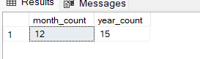

## Joins

### Inner Join

 inner join is the *intersection* of the two tables.

--Write a query that displays player names, school names and conferences for schools in the "FBS (Division I-A Teams)" division.

select players.player_name, players.school_name, teams.conference

from college_football_players players

inner join college_football_teams teams

on players.school_name = teams.school_name

where division = 'FBS (Division I-A Teams)'

Outer joins

Outer joins are joins that return matched values and unmatched values from either or both tables. There are a few types of outer joins:

* [LEFT JOIN returns only unmatched rows from the left table](https://mode.com/sql-tutorial/sql-left-join), as well as matched rows in both tables.
* [RIGHT JOIN returns only unmatched rows from the right table](https://mode.com/sql-tutorial/sql-right-join) , as well as matched rows in both tables.
* [FULL OUTER JOIN returns unmatched rows from both tables,](https://mode.com/sql-tutorial/sql-full-outer-join)as well as matched rows in both tables.

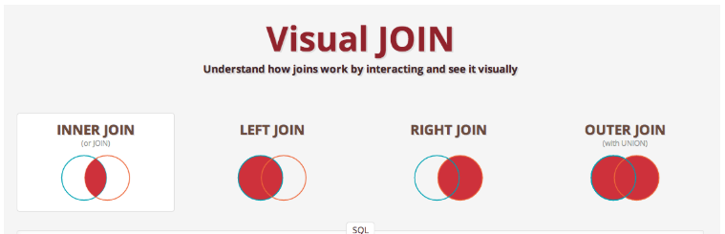

select * from crunchbase_acquisitions

where company_permalink = '/company/280-north'



SELECT companies.permalink AS companies_permalink,

companies.name AS companies_name,

acquisitions.company_permalink AS acquisitions_permalink,

acquisitions.acquired_at AS acquired_date

FROM crunchbase_companies companies

JOIN crunchbase_acquisitions acquisitions

ON companies.permalink = acquisitions.company_permalink

where companies.permalink = '/company/280-north'

SELECT companies.permalink AS companies_permalink,

companies.name AS companies_name,

acquisitions.company_permalink AS acquisitions_permalink,

acquisitions.acquired_at AS acquired_date

FROM crunchbase_companies companies

LEFT JOIN crunchbase_acquisitions acquisitions

ON companies.permalink = acquisitions.company_permalink

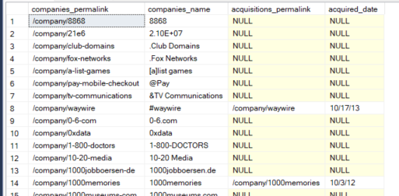

--Write a query that performs an inner join between the tutorial.crunchbase_acquisitions table and the tutorial.crunchbase_companies table,

--but instead of listing individual rows, count the number of non-null rows in each table.

select count(ac.company_permalink) ac_permalink , count(co.permalink) as co_permalink

from crunchbase_acquisitions ac

inner join crunchbase_companies co

on co.permalink = ac.company_permalink

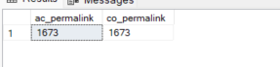

--Modify the query above to be a LEFT JOIN. Note the difference in results.

select count(ac.company_permalink) ac_permalink , count(co.permalink) as co_permalink

from crunchbase_acquisitions ac

left join crunchbase_companies co

on co.permalink = ac.company_permalink

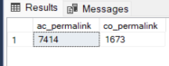

--Count the number of unique companies (don't double-count companies) and unique acquired companies by state.

--Do not include results for which there is no state data,

--and order by the number of acquired companies from highest to lowest.

select company_state_code, count(distinct company_name) as company_name, count(distinct name) as ac_name

from crunchbase_companies co

inner join crunchbase_acquisitions ac

on co.permalink = ac.company_permalink

where company_state_code <> ''

group by company_state_code

order by ac_name desc

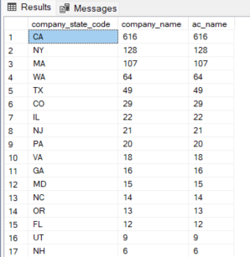

--Rewrite the previous practice query in which you counted total and acquired companies by state,

--but with a RIGHT JOIN instead of a LEFT JOIN. The goal is to produce the exact same results.

select company_state_code, count(distinct company_name) as company_name, count(distinct name) as ac_name

from crunchbase_acquisitions ac

right join crunchbase_companies co

on ac.company_permalink = co.permalink

where company_state_code <> ''

group by company_state_code

order by ac_name desc



### Filtering in the ON clause

SELECT companies.permalink AS companies_permalink,

companies.name AS companies_name,

acquisitions.company_permalink AS acquisitions_permalink,

acquisitions.acquired_at AS acquired_date

FROM crunchbase_companies companies

LEFT JOIN crunchbase_acquisitions acquisitions

ON companies.permalink = acquisitions.company_permalink

ORDER BY 1

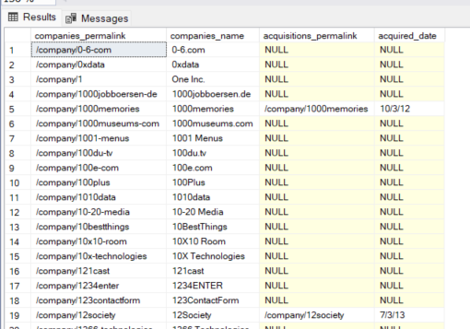

SELECT companies.permalink AS companies_permalink,

companies.name AS companies_name,

acquisitions.company_permalink AS acquisitions_permalink,

acquisitions.acquired_at AS acquired_date

FROM crunchbase_companies companies

LEFT JOIN crunchbase_acquisitions acquisitions

ON companies.permalink = acquisitions.company_permalink

AND acquisitions.company_permalink != '/company/1000memories'

ORDER BY 1

### El AND se ejecuta antes del join, es como un where para una sola tabla

--Filtering in the WHERE clause

SELECT companies.permalink AS companies_permalink,

companies.name AS companies_name,

acquisitions.company_permalink AS acquisitions_permalink,

acquisitions.acquired_at AS acquired_date

FROM crunchbase_companies companies

LEFT JOIN crunchbase_acquisitions acquisitions

ON companies.permalink = acquisitions.company_permalink

WHERE acquisitions.company_permalink != '/company/1000memories'

OR acquisitions.company_permalink IS NULL

ORDER BY 1

filter happens after the tables are joined

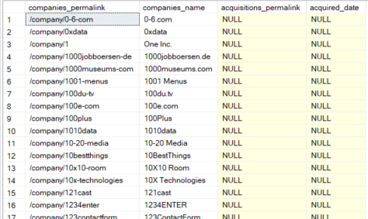

--Write a query that shows a company's name, "status" (found in the Companies table),

--and the number of unique investors in that company.

--Order by the number of investors from most to fewest.

--Limit to only companies in the state of New York.

select co.name as company, co.status, count(distinct inv.investor_name) AS count_inversors

from crunchbase_companies co

left join crunchbase_investments inv

on co.permalink = inv.company_permalink

where co.state_code = 'NY'

group by co.name, co.status

order by 3 desc

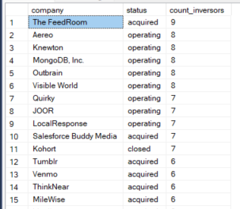

-- Write a query that lists investors based on the number of companies in which they are invested.

-- Include a row for companies with no investor,

-- and order from most companies to least.

select

case when investor_name is null then 'No Inversors' else investor_name end as inversor,

count(distinct co.permalink) as count_companies

from crunchbase_companies co

left join crunchbase_investments inv

on co.permalink = inv.company_permalink

group by investor_name

order by 2 desc

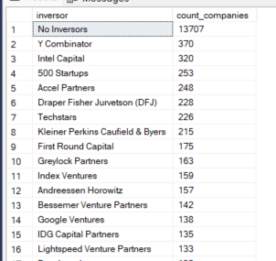

### The SQL FULL JOIN command

Returns unmatched rows from both tables.

SELECT COUNT(CASE WHEN companies.permalink IS NOT NULL AND acquisitions.company_permalink IS NULL

THEN companies.permalink ELSE NULL END) AS companies_only,

COUNT(CASE WHEN companies.permalink IS NOT NULL AND acquisitions.company_permalink IS NOT NULL

THEN companies.permalink ELSE NULL END) AS both_tables,

COUNT(CASE WHEN companies.permalink IS NULL AND acquisitions.company_permalink IS NOT NULL

THEN acquisitions.company_permalink ELSE NULL END) AS acquisitions_only

FROM crunchbase_companies companies

FULL JOIN crunchbase_acquisitions acquisitions

ON companies.permalink = acquisitions.company_permalink

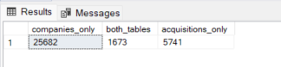

--Write a query that joins crunchbase_companies and crunchbase_investments_part1 using a FULL JOIN.

--Count up the number of rows that are matched/unmatched as in the example above.

SELECT COUNT(CASE WHEN co.permalink IS NOT NULL AND inv.company_permalink IS NULL

THEN co.permalink ELSE NULL END) AS companies_only,

COUNT(CASE WHEN co.permalink IS NOT NULL AND inv.company_permalink IS NOT NULL

THEN co.permalink ELSE NULL END) AS both_tables,

COUNT(CASE WHEN co.permalink IS NULL AND inv.company_permalink IS NOT NULL

THEN inv.company_permalink ELSE NULL END) AS investments_only

FROM crunchbase_companies co

FULL JOIN crunchbase_investments inv

ON co.permalink = inv.company_permalink

### The SQL UNION operator

UNION allows you to write two separate SELECT statements,

and to have the results of one statement display in the same table as the results from the other statement.

UNION only appends distinct values.

 If you'd like to append all the values from the second table, use UNION ALL.

SQL has strict rules for appending data:

1. Both tables must have the same number of columns
2. The columns must have the same data types in the same order as the first table

--Write a query that appends the two crunchbase_investments datasets above (including duplicate values).

--Filter the first dataset to only companies with names that start with the letter "T",

--and filter the second to companies with names starting with "M" (both not case-sensitive).

--Only include the company_permalink, company_name, and investor_name columns.

select co.permalink, co.name, inv.investor_name

FROM crunchbase_companies co

inner JOIN crunchbase_investments inv

ON co.permalink = inv.company_permalink

and co.name >= 'M'

and co.name < 'N'

UNION ALL

select co.permalink, co.name, inv.investor_name

FROM crunchbase_companies co

inner JOIN crunchbase_investments inv

ON co.permalink = inv.company_permalink

and co.name >= 'T'

and co.name < 'U'

select 'DATA1' as dataset, co.status , count(distinct inv.investor_name) as count_investors

FROM crunchbase_companies co

left JOIN crunchbase_investments inv

ON co.permalink = inv.company_permalink

group by co.status

union all

select 'DATA2' as dataset, co.status , count(distinct inv.investor_name) as count_investors

FROM crunchbase_companies co

left JOIN crunchbase_investments inv

ON co.permalink = inv.company_permalink

group by co.status

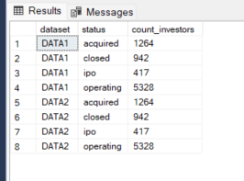

### Using comparison operators with joins

--using > to join only investments that occurred more than 5 years after each company's founding year:

SELECT companies.permalink,

companies.name,

companies.status,

COUNT(investments.investor_permalink) AS investors

FROM crunchbase_companies companies

LEFT JOIN crunchbase_investments investments

ON companies.permalink = investments.company_permalink

AND investments.funded_year > companies.founded_year + 5

GROUP BY companies.permalink,

companies.name,

companies.status

--Joining on multiple keys

--the results of the following query will be the same with or without the last line.

--However, it is possible to optimize the database such that the query runs more quickly with the last line included:

SELECT companies.permalink,

companies.name,

investments.company_name,

investments.company_permalink

FROM crunchbase_companies companies

LEFT JOIN crunchbase_investments investments

ON companies.permalink = investments.company_permalink

AND companies.name = investments.company_name

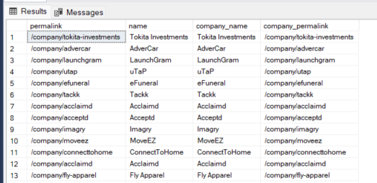

## Self joining tables

--Identify companies that received an investment from Great Britain following an investment from Japan.

SELECT DISTINCT japan_investments.company_name,

japan_investments.company_permalink

FROM crunchbase_investments japan_investments

JOIN crunchbase_investments gb_investments

ON japan_investments.company_name = gb_investments.company_name

AND gb_investments.investor_country_code = 'GBR'

AND gb_investments.funded_at > japan_investments.funded_at

WHERE japan_investments.investor_country_code = 'JPN'

ORDER BY 1

# [Advanced SQL](https://mode.com/sql-tutorial/intro-to-advanced-sql)

## Changing a column's data type

--Changing a column's data type

--can use CAST or CONVERT to change the data type

--Using SQL String Functions to Clean Data

SELECT * FROM sf_crime_incidents_2014_01

--Cleaning strings

--LEFT, RIGHT, and LENGTH

SELECT incidnt_num,

date,

LEFT(date, 10) AS cleaned_date

FROM sf_crime_incidents_2014_01

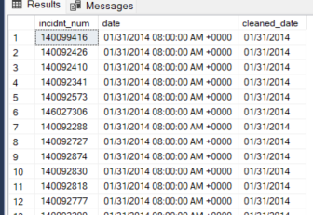

--RIGHT cuenta desde atrás para adelante

SELECT incidnt_num,

date,

LEFT(date, 10) AS cleaned_date,

RIGHT(date, 17) AS cleaned_time

FROM sf_crime_incidents_2014_01

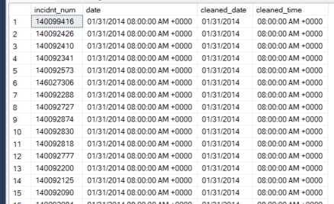

--The LEN function returns the length of a string

SELECT incidnt_num,

date,

LEFT(date, 10) AS cleaned_date,

RIGHT(date, LEN(date) - 11) AS cleaned_time

FROM sf_crime_incidents_2014_01

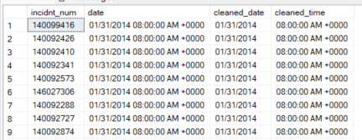

-- TRIM

--TRIM( \\[ [{LEADING | TRAILING | BOTH}\\] [removal_character]

--FROM ] target_string )

--LEADING, TRAILING, or BOTH defines whether to remove the removal_character at the beginning, end,

--or on both sides of target_string, respectively.

--If omitted, this defaults to BOTH.

SELECT location,

TRIM(both '()' FROM location)

FROM sf_crime_incidents_2014_01

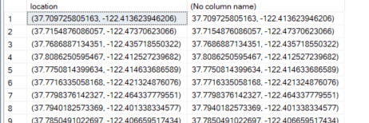

SELECT TRIM('#! ' FROM ' #SQL Tutorial! ') AS TrimmedString;



--CHARINDEX -- EN VEZ DE POSITION and STRPOS

--position and strpos no son soportados por sql.

-- SELECT POSITION( 'DELHI' IN 'NEW DELHI') AS POSITION_DELHI;

SELECT CHARINDEX('a', 'database' ) AS position



--SUBSTRING EN VEZ DE SUBSTR

SELECT SUBSTRING('database', 2, 3) as subcadena;

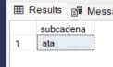

--Write a query that separates the `location` field into separate fields for latitude and longitude.

--You can compare your results against the actual `lat` and `lon` fields in the table.

select location,

substring(location, 2, CHARINDEX(',', location)-2) as latitude,

lat,

substring(location, CHARINDEX(',', location)+1, len(location)-(CHARINDEX(',', location)+1) ) as longitud,

lon

FROM sf_crime_incidents_2014_01

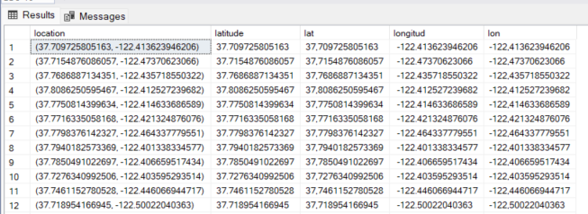

--CONCAT

SELECT CONCAT('W3Schools', '.com');



--Concatenate the lat and lon fields to form a field that is equivalent to the location field. (Note that the answer will have a different decimal precision.)

select lon, lat, location,

concat('(',lat, ',', lon, ')') as new_location

FROM sf_crime_incidents_2014_01

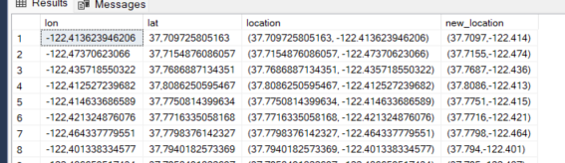

--Write a query that creates a date column formatted YYYY-MM-DD.

select date,

substring(date, 1,2) as day,

substring(date, 4,2) as month,

substring(date, 7,4) as year,

concat(substring(date, 7,4), '-', substring(date, 1,2), '-', substring(date, 4,2)) as new_date

FROM sf_crime_incidents_2014_01

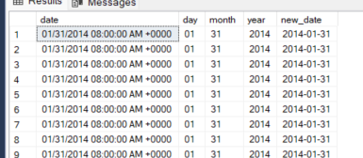

SELECT incidnt_num,

address,

UPPER(address) AS address_upper,

LOWER(address) AS address_lower

FROM sf_crime_incidents_2014_01

-- COALESCE

-- replace the nulls values

SELECT incidnt_num,

descript,

COALESCE(descript, 'No Description')

FROM tutorial.sf_crime_incidents_cleandate

ORDER BY descript DESC

--The COALESCE() function returns the first non-null value in a list.

SELECT COALESCE(NULL, NULL, NULL, 'W3Schools.com', NULL, 'Example.com');



SELECT

first_name,

last_name,

COALESCE(marital_status,'Unknown')

FROM persons

## Subquery basics

--Write a query that selects all Warrant Arrests from the sf_crime_incidents_2014_01 dataset,

--then wrap it in an outer query that only displays unresolved incidents.

select arrests.*

from (

select * from sf_crime_incidents_2014_01

where descript = 'WARRANT ARREST'

) as arrests

where arrests.resolution = 'NONE'

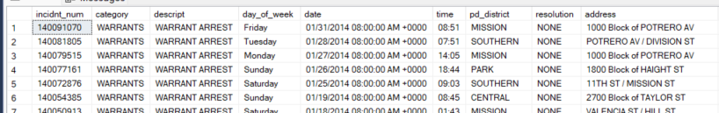

--Write a query that displays the average number of monthly incidents for each category.

--Hint: use tutorial.sf_crime_incidents_cleandate to make your life a little easier.

select incidents.category, AVG(incidents.cantidad) as average

from (

select category, substring(date, 1, 2) as month, count(*) as cantidad

from sf_crime_incidents_cleandate

group by category, substring(date, 1, 2)

) as incidents

group by incidents.category

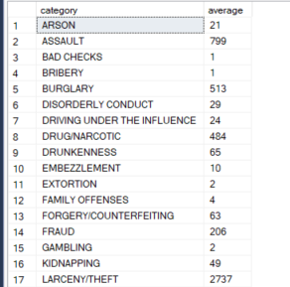

### Subqueries in conditional logic

--all of the entries from the earliest date

select *

from sf_crime_incidents_2014_01

where date = ( select min(date) from sf_crime_incidents_2014_01)

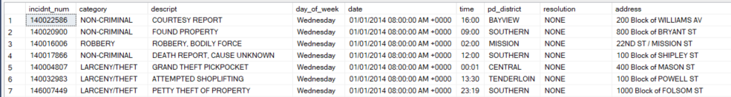

--Most conditional logic will work with subqueries containing one-cell results

select *

from sf_crime_incidents_2014_01

where date in (

select top 5 date

from sf_crime_incidents_2014_01

order by date

)

--Joining subqueries

--es la misma query que la anterior.

select *

from sf_crime_incidents_2014_01 incidents

join (

select top 5 date

from sf_crime_incidents_2014_01

order by date

)sub

on incidents.date = sub.date

select incidents.*,

sub.incidents as incidents_that_day

from sf_crime_incidents_2014_01 incidents

join (

select date,

count(incidnt_num) as incidents

from sf_crime_incidents_2014_01

group by date

) sub

on incidents.date = sub.date

order by sub.incidents desc, time

--Write a query that displays all rows from the three categories with the fewest incidents reported.

select inc.*, sub.incident_number

from sf_crime_incidents_2014_01 as inc

join (

select top 3 category, count(incidnt_num) as incident_number

from sf_crime_incidents_2014_01

group by category

order by count(incidnt_num)

)sub

on inc.category = sub.category

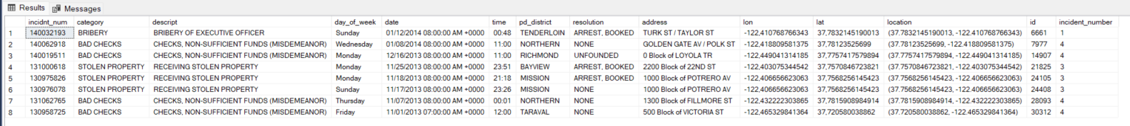

--Write a query that counts the number of companies founded and acquired by quarter starting in Q1 2012.

--Create the aggregations in two separate queries, then join them.

select coalesce(com.founded_quarter,ac.acquired_quarter) as quarter, com.count_founded_quarter, ac.count_acq_quarter

from

(

select founded_quarter, count(founded_quarter) as count_founded_quarter

from crunchbase_companies

where founded_quarter >= '2012-Q1'

group by founded_quarter

) as com

join (

select acquired_quarter, count(acquired_quarter) as count_acq_quarter

from crunchbase_acquisitions

where acquired_quarter >= '2012-Q1'

group by acquired_quarter

) AS ac

on ac.acquired_quarter = com.founded_quarter

order by 1

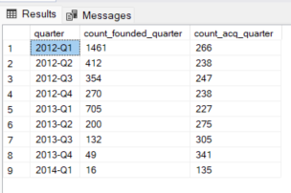

--Write a query that ranks investors from the combined dataset above by the total number of investments they have made.

select investor_name, count(investor_name) as total_number_investments

from (

select *

from crunchbase_investments

union all

select *

from crunchbase_investments_part2

)as inv

group by investor_name

order by investor_name

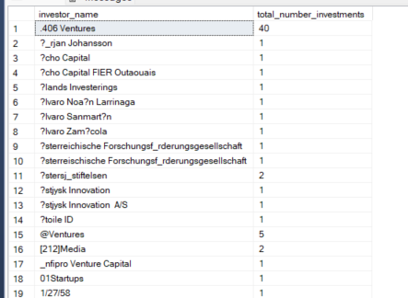

--Write a query that does the same thing as in the previous problem,

--except only for companies that are still operating.

--Hint: operating status is in tutorial.crunchbase_companies.

select investor_name, count(investor_name) as total_number_investments

from (

select investor_name

from crunchbase_investments inv

inner join crunchbase_companies co

on co.permalink = inv.company_permalink

where status = 'operating'

union all

select investor_name

from crunchbase_investments_part2 inv2

inner join crunchbase_companies com

on com.permalink = inv2.company_permalink

where status = 'operating'

) as invest

group by investor_name

order by 2 desc

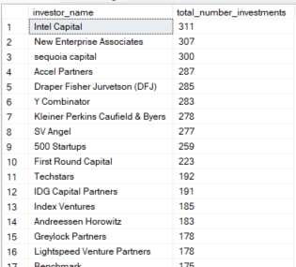

## Window Functions

SELECT duration_seconds, start_time,

SUM(duration_seconds) OVER (ORDER BY start_time) AS running_total

FROM dc_bikeshare_q1_2012

order by start_time

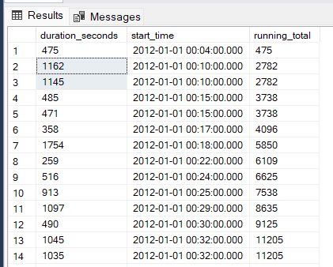

SELECT duration_seconds,

SUM(duration_seconds) OVER (ORDER BY start_time) AS running_total

FROM dc_bikeshare_q1_2012

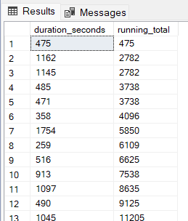

--suma los segundos agrupados por terminal y ordenados por start_time

select start_terminal, start_time, duration_seconds,

sum(duration_seconds) over

(partition by start_terminal order by start_time) as running_total

from dc_bikeshare_q1_2012

where start_time < '2012-01-08'

order by start_time

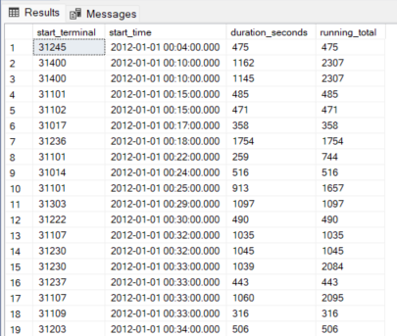

-- you can't include window functions in a GROUP BY clause.

--Write a query modification of the above example query that

--shows the duration of each ride as a percentage of the total time accrued by riders

--from each start_terminal

select start_terminal, duration_seconds,

sum(duration_seconds) over(partition by start_terminal) as suma,

(duration_seconds / sum(duration_seconds) over(partition by start_terminal ) ) *100 as promedio

from dc_bikeshare_q1_2012

order by 1,4

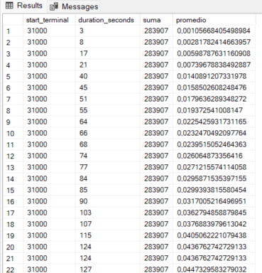

SELECT start_terminal,

duration_seconds,

SUM(duration_seconds) OVER

(PARTITION BY start_terminal) AS running_total,

COUNT(duration_seconds) OVER

(PARTITION BY start_terminal) AS running_count,

AVG(duration_seconds) OVER

(PARTITION BY start_terminal) AS running_avg

FROM dc_bikeshare_q1_2012

WHERE start_time < '2012-01-08'

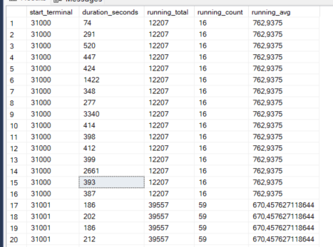

-- with order by

SELECT start_terminal,

start_time,

duration_seconds,

SUM(duration_seconds) OVER

(PARTITION BY start_terminal ORDER BY start_time)

AS running_total,

COUNT(duration_seconds) OVER

(PARTITION BY start_terminal ORDER BY start_time)

AS running_count,

AVG(duration_seconds) OVER

(PARTITION BY start_terminal ORDER BY start_time)

AS running_avg

FROM dc_bikeshare_q1_2012

WHERE start_time < '2012-01-08'

order by 1, 2

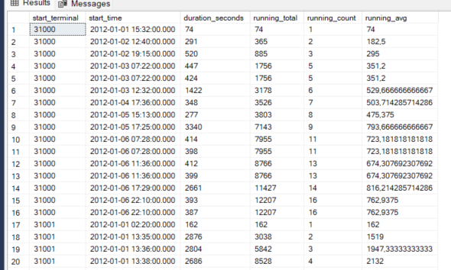

-- Write a query that shows a running total of the duration of bike rides (similar to the last example),

--but grouped by end_terminal,

--and with ride duration sorted in descending order.

SELECT end_terminal,

duration_seconds,

SUM(duration_seconds) OVER

(PARTITION BY end_terminal ORDER BY duration_seconds desc)

AS running_total

FROM dc_bikeshare_q1_2012

WHERE start_time < '2012-01-08'

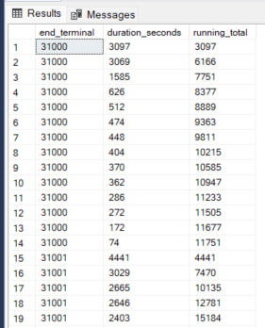

--ROW_NUMBER()

Select

start_terminal,

start_time,

duration_seconds,

row_number() over (order by start_time) as row_number

FROM dc_bikeshare_q1_2012

WHERE start_time < '2012-01-08'

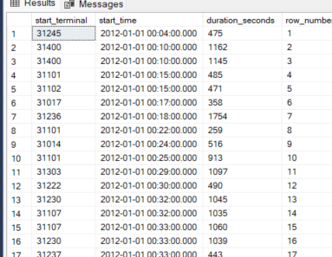

Select

start_terminal,

start_time,

duration_seconds,

row_number() over (partition by start_terminal order by start_time) as row_number

FROM dc_bikeshare_q1_2012

WHERE start_time < '2012-01-08'

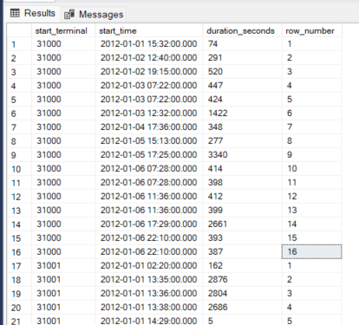

### RANK() and DENSE_RANK()

Select

start_terminal,

start_time,

duration_seconds,

rank() over (partition by start_terminal order by start_time) as rank

FROM dc_bikeshare_q1_2012

WHERE start_time < '2012-01-08'

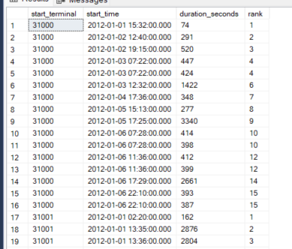

Select

start_terminal,

start_time,

duration_seconds,

dense_rank() over (partition by start_terminal order by start_time) as dense_rank

FROM dc_bikeshare_q1_2012

WHERE start_time < '2012-01-08'

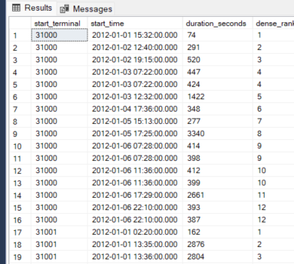

--Write a query that shows the 5 longest rides from each starting terminal,

--ordered by terminal,

--and longest to shortest rides within each terminal.

--Limit to rides that occurred before Jan. 8, 2012.

select *

from

(

select start_terminal,

duration_seconds,

rank() over (partition by start_terminal order by duration_seconds desc ) as rank

FROM dc_bikeshare_q1_2012

WHERE start_time < '2012-01-08'

) sub

where sub.rank <= 5

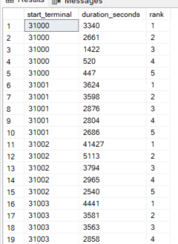

--NTILE

-- divide la partición en el número que tiene entre parentesis.

SELECT start_terminal,

duration_seconds,

NTILE(4) OVER

(PARTITION BY start_terminal ORDER BY duration_seconds)

AS quartile,

NTILE(5) OVER

(PARTITION BY start_terminal ORDER BY duration_seconds)

AS quintile,

NTILE(100) OVER

(PARTITION BY start_terminal ORDER BY duration_seconds)

AS percentile

FROM dc_bikeshare_q1_2012

WHERE start_time < '2012-01-08'

ORDER BY start_terminal, duration_seconds

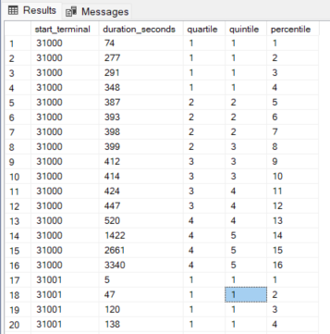

-- Write a query that shows only the duration of the trip and

--the percentile into which that duration falls (across the entire dataset—not partitioned by terminal).

select duration_seconds,

NTILE(100) over(order by duration_seconds) as percentile

FROM dc_bikeshare_q1_2012

WHERE start_time < '2012-01-08'

order by 1 desc

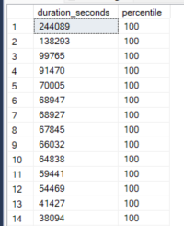

-- LAG and LEAD

-- lag pone el registro anterior y lead el registro posterior.

SELECT start_terminal,

duration_seconds,

LAG(duration_seconds, 1) OVER

(PARTITION BY start_terminal ORDER BY duration_seconds) AS lag,

LEAD(duration_seconds, 1) OVER

(PARTITION BY start_terminal ORDER BY duration_seconds) AS lead

FROM dc_bikeshare_q1_2012

WHERE start_time < '2012-01-08'

ORDER BY start_terminal, duration_seconds

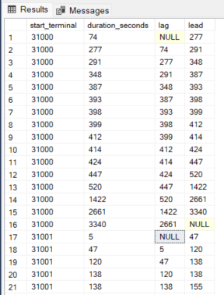

--This is especially useful if you want to calculate differences between rows:

SELECT start_terminal,

duration_seconds,

duration_seconds -

LAG(duration_seconds, 1) OVER (PARTITION BY start_terminal ORDER BY duration_seconds) AS difference

FROM dc_bikeshare_q1_2012

WHERE start_time < '2012-01-08'

ORDER BY start_terminal, duration_seconds

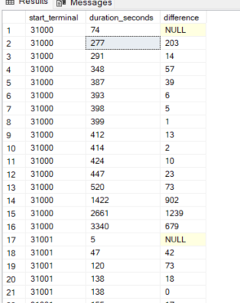

--Defining a window alias

SELECT start_terminal,

duration_seconds,

NTILE(4) OVER ntile_window AS quartile,

NTILE(5) OVER ntile_window AS quintile,

NTILE(100) OVER ntile_window AS percentile

FROM dc_bikeshare_q1_2012

WHERE start_time < '2012-01-08'

WINDOW ntile_window AS

(PARTITION BY start_terminal ORDER BY duration_seconds)

ORDER BY start_terminal, duration_seconds

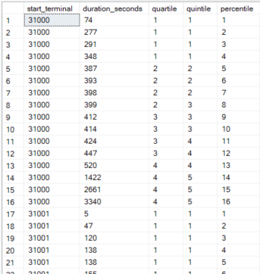

--Pivoting rows to columns

SELECT teams.conference AS conference,

players.year,

COUNT(1) AS players

FROM college_football_players players

JOIN college_football_teams teams

ON teams.school_name = players.school_name

GROUP BY teams.conference, players.year

ORDER BY 1,2

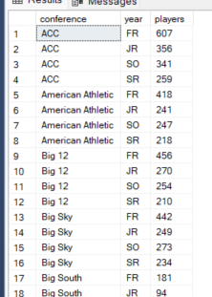

SELECT conference,

SUM(CASE WHEN year = 'FR' THEN players ELSE 0 END) AS fr,

SUM(CASE WHEN year = 'SO' THEN players ELSE 0 END) AS so,

SUM(CASE WHEN year = 'JR' THEN players ELSE 0 END) AS jr,

SUM(CASE WHEN year = 'SR' THEN players ELSE 0 END) AS sr

FROM (

SELECT teams.conference,

players.year,

COUNT(1) AS players

FROM college_football_players players

JOIN college_football_teams teams

ON teams.school_name = players.school_name

GROUP BY teams.conference,players.year

) sub

GROUP BY conference

ORDER BY 1

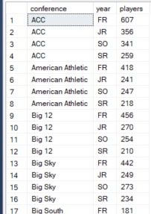

SELECT conference, [FR], [SO], [JR], [SR]

FROM

(

SELECT teams.conference,

players.year,

COUNT(1) AS players

FROM college_football_players players

JOIN college_football_teams teams

ON teams.school_name = players.school_name

GROUP BY teams.conference,players.year

) AS source

PIVOT

(

SUM(players)

FOR year IN([FR], [SO], [JR], [SR])

) AS pivot_table;

